**Set 1**

Q.1 Look at the data given below. Plot the data, find the outliers and find out $μ,σ,σ^{2}$

|  |  |
| --- | --- |
| **Name of company** | **Measure X** |
| Allied Signal | 24.23% |
| Bankers Trust | 25.53% |
| General Mills | 25.41% |
| ITT Industries | 24.14% |
| J.P.Morgan & Co. | 29.62% |
| Lehman Brothers | 28.25% |
| Marriott | 25.81% |
| MCI | 24.39% |
| Merrill Lynch | 40.26% |
| Microsoft | 32.95% |
| Morgan Stanley | 91.36% |
| Sun Microsystems | 25.99% |
| Travelers | 39.42% |
| US Airways | 26.71% |
| Warner-Lambert | 35.00% |

Ans

Code:

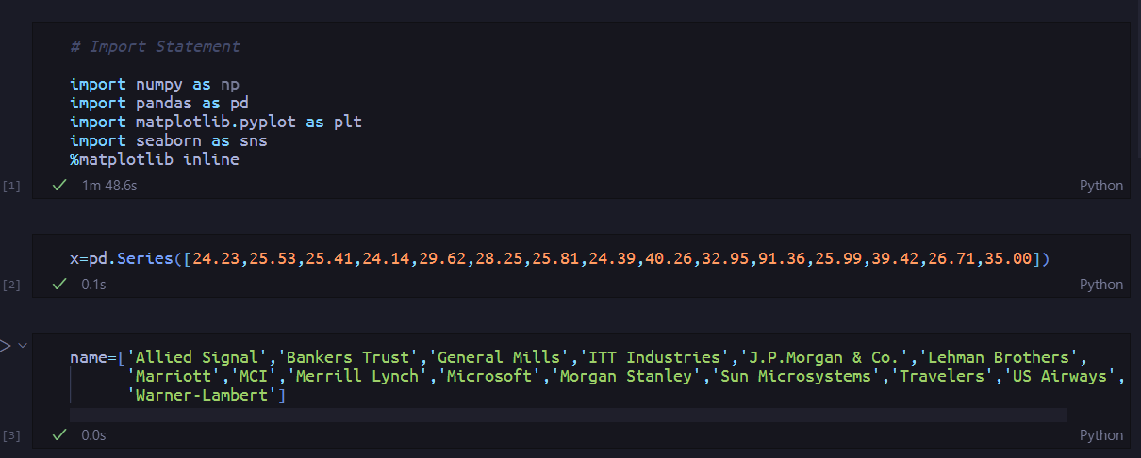

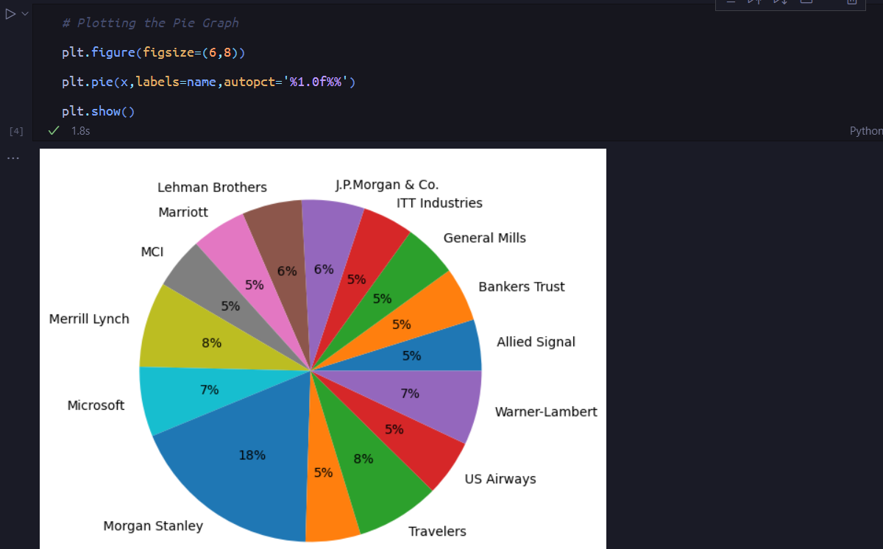

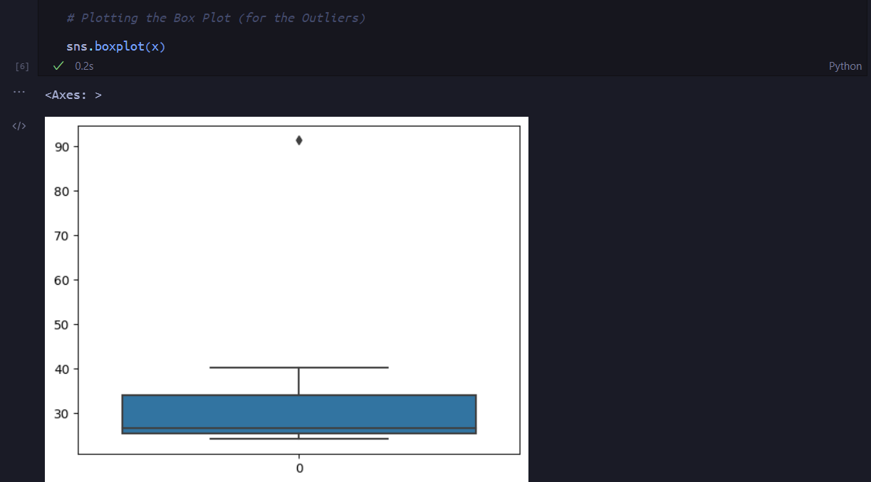

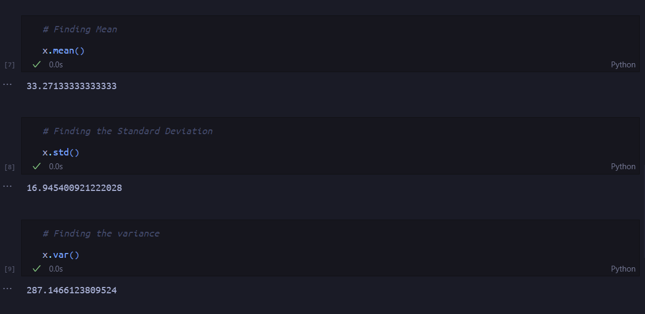

Therefore, μ = 33.27133333333333 , σ = 16.945400921222028, σ2 = 287.1466123809524

Q.2



Ans

(i)

Ans:

IQR = Q3 – Q2

12 – 5 = 7, this means that half of the data points (50%) lie in the range of 5 and 12

(ii)

Ans: The given dataset extends towards the right side of the curve therefore it is positively skewed.

(iii)

Ans: If the data point with value 25 is 2.5 then the interquartile range will change, however the median value will be the same.

Q.3



Answer the following three questions based on the histogram above.

1. Where would the mode of this dataset lie?

Ans. The mode of this data set would lie between 3 and 10.

1. Comment on the skewness of the dataset.

Ans. The given dataset extends towards the right side of the curve therefore it is positively skewed.

1. Suppose that the above histogram and the box-plot in question 2 are plotted for the same dataset. Explain how these graphs complement each other in providing information about any dataset.

Ans. There is an outlier of the value 25 and both the plot has positive skewness

Q4. AT&T was running commercials in 1990 aimed at luring back customers who had switched to one of the other long-distance phone service providers. One such commercial shows a businessman trying to reach Phoenix and mistakenly getting Fiji, where a half-naked native on a beach responds incomprehensibly in Polynesian. When asked about this advertisement, AT&T admitted that the portrayed incident did not actually take place but added that this was an enactment of something that “could happen.” Suppose that one in 200 long-distance telephone calls is misdirected. What is the probability that at least one in five attempted telephone calls reaches the wrong number? (Assume independence of attempts.)

Ans.

Let X be the probability of 1 call misdirected out of 200

Therefore the Probability of X occurring is 1/200

Therfore, we can say that P(X) = 1/200

Calculating the Probability of at least one successful call we get,

1 – P(X) = 1 – 1/200

= 199/200

= 0.967

Assuming every event is independent of other event, the Probability is

1 – (0.967)5

= 0.02475

Hence, the probability that at least one in five attempted telephone calls reaches the wrong number is 2%

5. Returns on a certain business venture, to the nearest $1,000, are known to follow the following probability distribution

|  |  |
| --- | --- |
| x | P(x) |
| -2,000 | 0.1 |
| -1,000 | 0.1 |
| 0 | 0.2 |
| 1000 | 0.2 |
| 2000 | 0.3 |
| 3000 | 0.1 |

(i). What is the most likely monetary outcome of the business venture?

Ans. The most likely monetary outcome of this business venture is $2000

(ii). Is the venture likely to be successful? Explain

Ans.

If we consider getting positive returns as a success, we must calculate the probability of the venture getting positive returns.

0.3 + 0.2 + 0.1 = 0.6,

0.6 * 100 = 60%

Therefore we can say that there is a 60% probability of the venture being successful.

(iii) What is the long-term average earning of business ventures of this kind? Explain

Ans.

(-2000*0.1)+(-1000*0.1)+(0*0.2)+(1000*0.2)+(2000 *0.3)+(3000*0.1) = 800

Therefore the long term average earning of a business venture of this kind would be around $800.

(iv) What is the good measure of the risk involved in a venture of this kind? Compute this measure

Ans To compute the measure of risk involved in a venture of this kind. We must calculate the Variance and the Standard Deviation of x.

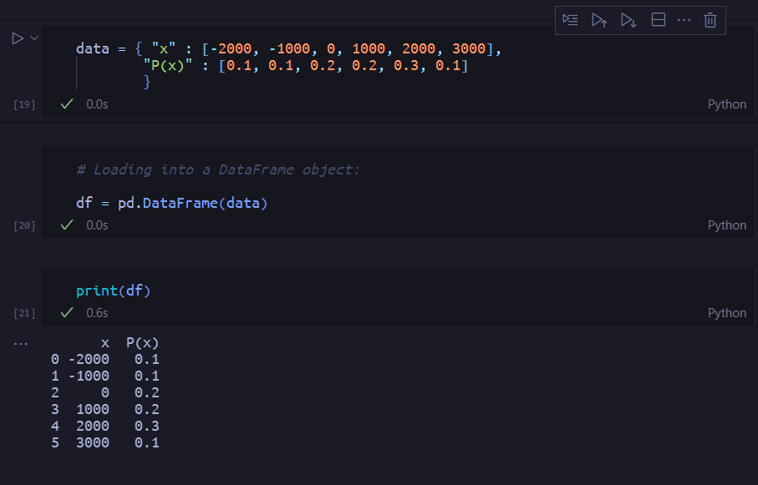

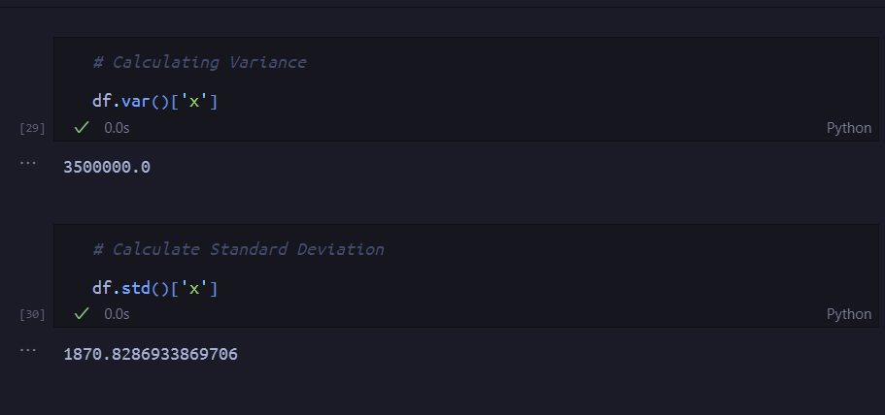

Variance = 3500000

Standard Deviation = 1870.83

Therefore the value of standard deviation is $1870, with an average return of $800 this venture can be considered highly risky.